
JavaScript and jQuery Class
Instructor Teresa Pelkie
Week 15 - bit.ly/js-c15
Chapter 10 How to work with forms and data validation

HTML Forms Overview
HTML forms are typically used to collect information which must be sent to a server or processed by a script in order to make use of the data. A form can contain input elements like text fields, checkboxes, radio-buttons, submit buttons and more. A form can also contain select lists, textarea, fieldset, legend, and label elements which do not contain data. form elements can also be programed to perform client-sided interactivity..

The <form> tag creates the HTML form and enclose the elements and other content:

<form>

</form>

Server technologies that work with HTML forms:
- CGI / PERL
- ASPX
- PHP
- JSP

Form tag attributes:
<form action=”” method= “” name=”” id=””> </form>

Action
The action attribute is required! It specifies where to send the form data, which are the name/value pairs, when the form is submitted.
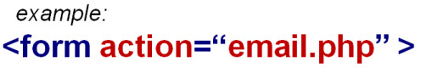

Note: Forms can be used for other reasons than processing information. In this case, the action could call a JavaScript program that could cause some kind of interactivity.

Method
The method attribute specifies how to send form data. The data can be sent in the address bar as a URL (with method="get") or in the body of the message (request) as HTTP post
(with method="post").
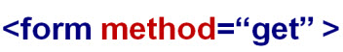

The <input> element
- Textbox - <input type=”text”>
- Checkbox - <input type=”checkbox”>
A checkbox group is a group of choices that are related in some way.
- They may all have the same “name” attribute
- or they can have different “name” attributes.
- They must have a unique “value” attribute so we can identify which was checked.
- You can check more than one box.

- Radio buttons - <input type=”radio”>
A radio button group is a group of choices that are related in some way. They are “mutually exclusive”, meaning you can only check one button. They must all have the same “name” attribute. They must all have a unique “value” attribute so we can identify which one was checked. Radio buttons are also called option buttons.
- Submit button - <input type=”submit”> - calls the “action” of the form
- Reset button - <input type=”reset”>

The <select> and <option> element - drop down list

The <textarea> </textarea> element - large multiline text box

Form Elements Attributes
- name - identifies the element for the server
- id - identifies the element for the CSS and JS
- value - identifies the user’s entry or choice

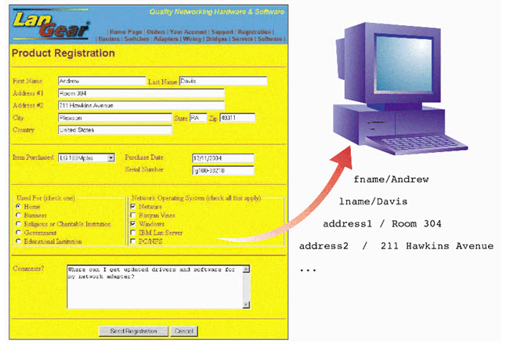
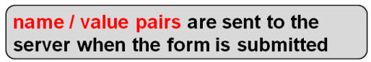

Using jQuery with Forms

Form Selectors
http://api.jquery.com/category/forms/

:input $(":input") All input elements
:text $(":text") All input elements with type="text"
:password $(":password") All input elements with type="password"

:radio $(":radio") All input elements with type="radio"
:checkbox $(":checkbox") All input elements with type="checkbox"

:submit $(":submit") All input elements with type="submit"
:reset $(":reset") All input elements with type="reset"
:button $(":button") All input elements with type="button"

:image $(":image") All input elements with type="image"
:file $(":file") All input elements with type="file"

:enabled $(":enabled") All enabled input elements
:disabled $(":disabled") All disabled input elements
:selected $(":selected") All selected input elements
:checked $(":checked") All checked input elements

:focus $(“:focus”) Selects the element if it currently has focus

Form Events
- http://api.jquery.com/category/events/form-events/
- change() - when the value changes
- focus() - when the element is clicked into
- blur() - when focus is taken off
- select() - when the select element is selected
- submit() - when the form is submitted to the action
- reset() - form fields are cleared

val() method
retrieve a value
http://api.jquery.com/val/ - gets the current value of the first element in the set of matched elements.

The .val() method is primarily used to get the values of form elements such as input, select and textarea. In the case of <select multiple="multiple"> elements, the .val() method returns an array containing each selected option; if no option is selected, it returns null. For selects, radios, and checkboxes, you can also use the :selected and :checked selectors to get at values.

set a value
The .val() method can also set a value in an <input> element, as shown below.

var text = “xyz”;
$("input").val(text);

val() can take a function
function(index, value)
The .val() method allows us to set the value by passing in a function, as shown below

$(this).val(function( i, val ) {
return val.toUpperCase();
});

Retrieving Values in Form Elements

Find the value the user entered in a textbox

Note: this will also apply to the <select> element and the <textarea> element because these types of elements are single controls, as opposed to groups like radio and checkboxes. You can also code checkboxes as single control using a different name attribute for each checkbox.

Procedure #1 - apply the ‘val()’ method to retrieve the value on a button click

Example
<input type="text" id="name" name="name" >

$('#btn').click(function(){

var theName = $('#name').val(); // also can use ‘this’ - var theName = $(this).val();

alert(theName);

}); // end click

Procedure #2 - apply the val()’ method to retrieve the value on a change() event

Example
<input type="text" id="name" name="name" >

$('#name').change(function(){
var theName = $('#name').val();
alert(theName);
}); // end change

Retrieving values in a checkbox that is “checked”
http://api.jquery.com/checked-selector/

Single check box
$(':checkbox:checked').val();

Multiple check boxes / check box group
must ‘loop’ through all of the check boxes and determine if it is checked

$(":checkbox:checked").each(
function() {

}); //end each

Retrieving a value in a radio group where one is “checked”
Because radio buttons are mutually exclusive a group will only return one value

Radio box group
$(':radio:checked').val();

$(':radio[name=color]:checked').val();

Retrieving a value in a dropdown list where one option is “selected”
http://api.jquery.com/selected-selector/

Because drop down lists are usually mutually exclusive a group will only return one value. They can return multiple values by using the ‘multiple’ attribute.

Select and Option elements
$('select').val();
$('select[name=cars]').val();

Common Techniques used with Forms

Give Focus to an input box after a page loads
Procedure - apply the ‘focus()’ method

Example
<input type="text" id="name" name="name" >
$('#name').focus(); - reference the id
$('input:first').focus(); - use the first filter for the <input> element

Highlighting current fields
Procedure - find all of the textboxes ‘input[type=text]’ selector
- use the ‘addClass’ method to display the CSS using the focus() event
- use the ‘removeClass’ method to remove the CSS using the blur() event

Example
$('input[type=text]').focus(function(){
$(this).addClass('highlight');
}); // end focus

$('input[type=text]').blur(function(){
$(this).removeClass('highlight');
}); // end blur

Creating default text in a textbox
Procedure - set the HTML value attribute
- use the ‘focus()’ event to compare the value in the textbox to the default value,
if it is the same, clear it out
- use the ‘blur()’ event to compare the value in the textbox to the default value,
if there is no value, set it back to the default value

Example
<input type="text" id="name" name="name" value="Enter your name">

var defaultText = "Enter your name";

$('input:first').focus(function(){
if ($(this).val() == defaultText) {
$(this).val('');
}
}); //end focus

$('input:first').blur(function(){
if ($(this).val() == ''){
$(this).val(defaultText);
}
}); //end blur

Limiting the number of character in a textarea
- see example in sample code
Procedure - set the max number in a variable
- use the keypress event to count the length of the character
- when the max number is reached, prevent the default keypress

Creating a trigger to check all textboxes
- also see example in sample code to toggle on and off

Procedure - find all of the checkboxes ‘:checked’ selector
- use the ‘attr’ method to set the ‘checked’ property to true

Example
$('#btn').click(function(){
$(":checkbox").each(function() {

$(this).attr('checked', true);

}); //end each
}); // end click

Form Validation
Validation is the process of making sure that the field either has some value or if it has a value. Normally, there will be an indication that certain form fields are ‘required’. Before the form is submitted, you will call a function to check the elements and make sure that they have the required value. If not, you will halt the submission of the form so that the user can correct the entry. You will also give some kind of message to the user to indicate the problem.

Text boxes, select
can be validated by examining the value using val()

Check box group or radio group
can be validated by examining the length of the “checked’ items

Using Regular Expressions
https://developer.mozilla.org/en-US/docs/JavaScript/Guide/Regular_Expressions
see example in code samples

Regular expressions are patterns used to match character combinations in strings. They can be used to make sure that an expression, such as an email address, is in the correct format. However, the email may not actually exist, but the pattern is valid.

jQuery Validate Plugin
http://docs.jquery.com/Plugins/Validation

see example in code samples

